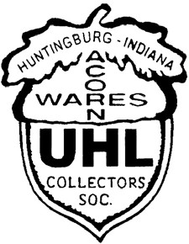

Visit us on the Web @

www.uhlcollectors.org
Russell A. Uhls

6718 Waverhill Dr. Indianapolis, IN 46217
Hm.: 317-536-8544
Work: 317-570-5830 ext. 205
Work Cell: 574-527-8994
Presorted Standard U.S. Postage Paid
Indianapolis, IN Permit

2010 Uhl Collectors’ Society
Annual Convention

Friday, June 25th & Saturday, June 26th

jxË Üx ÄÉÉ~|Çz yÉÜãtÜw àÉ áxx|Çz çÉâ |Ç
]táÑxÜ444

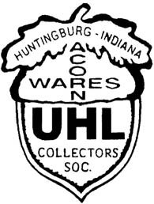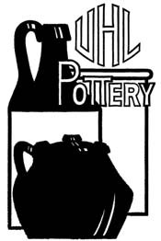Uhl Collectors Society

May 2010

**********************************************

From The President’s Desk

It was Saturday, April 24th and the weather was cloudy with a chance of tornadoes. I was going to Chip Kugler's auction (the-auction-company) in Jasper first. I got to see a piece I hadn't seen before. It was about a 4- inch pitcher with a bulbous bottom. It had a chip in its lip and had the hand made stamp on the bottom. It was brown and tan in color. Unique! I had not seen another one like it. It sold for $425. Feldmeier's added it to their collection.
Hilgemann's auction was my next stop.
Two crème de coffee jugs went for $20. A squat grape pitcher went for $55. 2 plain barrel pitchers went for
$30. Feldmeyer’s book brought $15. A covered casserole brought $20. A #120 tulip bulb bowl brought $30
Picket fence bowls were bringing $35. A McCurdy book brought $60. An acorn wares jug brought $35. A Acorn ware crock brought$ 45. A #5 jug brought $65. An Evansville #6 churn brought $360.
While the auctions were going on some members were selling their wares at the 4 H center in Evansville. Dan Hadley, Nathan Posey, Keith Miller and Fritz Puckett were wheeling and dealing. Several Uhl pieces changed hands.
Whew! Was it a busy Uhl day or what? Les
********************************************************************************

From the Press Secretary

Well here it is, time to head to Jasper for the convention. Roxanne and I are looking forward to enjoying the happenings and visiting with all.
Something that I did not have room for in the information section, but everyone needs to know is, the restaurant at the Jasper Inn has been closed as of this writing. This will not affect the Banquet as a different company does it.
While Roxanne & I were on a trip in Northern Indiana, we did a bit of “Picking”. We found a Creamer as shown In Anna Mary Feldmeyer’s book on page 146, plate 272. It is the upper right hand miniature in the plate. It may not be a rare piece, but it’s the first I ever have seen in the flesh. Not a bad find for $7.00! We were on our way back South and stopped in Wabash Indiana. Roxanne wasn’t too thrilled with the place. I found a “dealer” with 3 stories of “Items” in an 1800’s building with fire damage, roof leaks, aisles you had to walk sideways through, and some truly odd smells. I think the “Smells” were what got Roxanne… My kind of Hunting Ground! After talking “Jack” down on an item we paid for it and headed for home. It was a good trip! Be safe heading to Jasper and we’ll see you there!
Russ

What’s Inside
Page 2: Uhl Mission Statement Page 3: Notices & Information Page 2: 2010 Convention Agenda Page 3: Officers & Board Members Page 2: Newsletter Items & Requests Page 3: My Favorite Item

UHL Pottery Collector’s Society Mission Statement

The mission of the UHL pottery collector’s society is to provide an enjoyable structured group environment for those passionate about preserving, collecting & enjoying UHL pottery, which was manufactured between 1849 & 1944 in Evansville & Huntingburg Indiana.

Newsletter Items & Requests

As I stated the last issue, we now are for the most part all connected by the Internet, if you would prefer to receive the newsletter by email; I have started a mailing list of those members requesting it by email. You may contact me at: maundpauhls@comcast.net. You may request only an email copy or add the email copy.

PLEASE, bring with you to the convention or email me pictures of Items or articles I can share with the members in future newsletters. Help me make this publication fun & interesting for all! “Happy Uhlin g” Russ Uhls

Thursday June 24, 2010
2010 Convention Agenda

Early Registration for Auction Items 6:30-8:00 PM Pecan Room Hall

Friday June 25, 2010

Convention Registration 2:00-5:00 PM Banquet Hall
Auction Registration 3:00-5:00 PM Pecan Hall
Banquet Room Opens 5:30 PM Main Banquet Hall
Buffet Dinner 6:30PM
Auction-Chip Kugler Immediately after dinner
Room to Room Uhling Until vendors lock the doors

Saturday, June 26, 2010

Vendors set-up 7:00 AM Banquet Hall Convention 7:30 AM Banquet Hall Uhl Sale 7:30-9:00AM Banquet Hall Business Meeting 9:30AM Banquet Hall

OFFICERS

President: Les Bain
973 S. Lumbard Avenue
Evansville, IN 47714
812-589-7948
email: lbain@evs.k12.in.us

Vice Pres.: Norman & Sharon Patmore
P.O. Box 706
Santa Claus, IN 47579
812-544-2069
email: spatmore@psci.net

Sec. Treasurer: Sam & Amy Busler
398 South Star
Santa Claus, IN 47579
812-544-2987
email: casabusler@psci.net

Press Sec.: Russ & Roxanne Uhls
6718 Waverhill Dr. Indianapolis, IN 46217
Hm.: 317-536-8544
Work: 317-570-5830 ext. 205
Work Cell: 574-527-8994

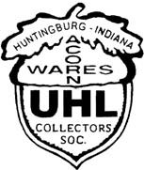

BOARD MEMBERS

Nathan Stewart
8088 N. Birch Dr. Newburgh, IN 47630
812-853-2913

Shawn & Terri Lynn Fehribach
8475 W 350 S Huntingburg, IN 47542
812-683-8380

Brian & Karla Neukam
560 Riverside Dr
Jasper, IN 47546
812-482-6168
Email: bneukam@psci.net
Notices & Information

It was voted on and approved, by your board of directors on May 2nd, 2010 that we will only be giving a total of 5 free collectables away with the other original items during the gift drawings.

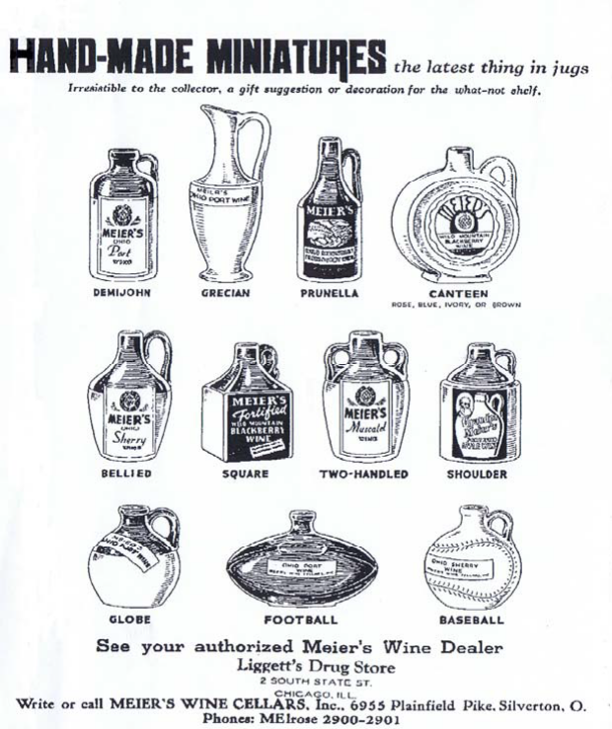Nathan Stewart’s 3-year term as board member is complete as of the upcoming convention. The board will miss him in his role. Please think about running or recommending someone to nominate to fill this open Board position.

“My Favorite Item”

Fellow Member Tom Uebelhor sent a favorite to share. This is an original Advertisement he found in an old Magazine.

“See your authorized Meier’s Wine Dealer” Liggett’s Drug Store
2 SOUTH STATE ST. CHICAGO, ILL.

What a neat find Tom!

